Project - Low Level Design

On

Healthcare Planning Assistant Agent

  - Course Name: Agentic AI

Institution Name: Medi-caps University – Data Gami Skill Based Course

Student Name(s) & Enrolment Number(s):
Sr no | Student Name | Enrolment Number
1. | Aayush | EN22IT301004
2. | Danish Shaikh | EN22IT301032
3. | Kashish Bilala | EN24CA5030079
4. | Komolika Vyas | EN24CA5030083
5. | Prakhar Jain | EN24CA5030122

Group Name: Group 04D12
Project Number: AAI 42
Industry Mentor Name: Ashwin
University Mentor Name: Ajeet Singh Rajput
Academic Year: 2025-26

Table of Contents
- Introduction.
  - Scope of the document.
  - Intended Audience
  - System overview.
- System Design.
  - Application Design
  - Process Flow
  - Information Flow
  - Components Design
  - Key Design Considerations
  - API Catalogue
  - UML Diagram
- References

1. Introduction
1.1 Scope of the Project
This document provides a detailed low-level design (LLD) for the Healthcare Planning Assistant Agent. It outlines system architecture, component-level design, workflows, APIs, and implementation details required to build an intelligent agent capable of planning healthcare-related tasks through multi-step reasoning. The document focuses on:
• Task decomposition logic
• Agent orchestration using frameworks like LangChain / CrewAI
• Integration with LLM APIs
• Mock healthcare tools and scheduling mechanisms

1.2 Intended Audience
This document is intended for:
• Software Developers (Backend / AI Engineers)
• System Architects
• Project Managers
• QA/Test Engineers
• Researchers working in Artificial Intelligence and healthcare automation

1.3 System Overview
The Healthcare Planning Assistant Agent is an intelligent system that:
• Accepts a high-level healthcare goal (e.g., “Find Treatment Options for Diabetes”)
- Uses an LLM-powered reasoning loop to:
- Break down goals into sub-tasks
- Validate required resources
- Manage dependencies
- Generate optimized execution plans
The system leverages:
• Large Language Models (LLMs)
• Agent frameworks (LangChain/CrewAI)
• Mock healthcare APIs (e.g., doctor availability, treatment database)

2. System Design
2.1 Application Design
The system follows a modular agent-based architecture where a central Planner Agent handles reasoning and task orchestration.
- The Planner Agent interprets user goals and decomposes them into smaller tasks
- Frameworks like LangChain or CrewAI are used to manage agent workflows
- The system integrates with LLM services via OpenAI API
- External tools (mock healthcare APIs) are used to validate and execute tasks
Key Features:
- Modular and scalable design
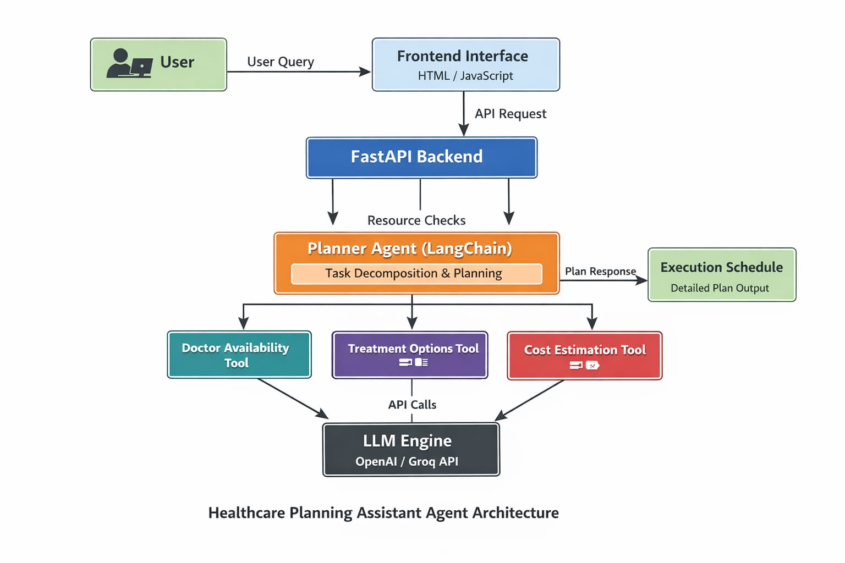
- Supports dynamic planning and execution
2.2 Process Flow
The system follows a step-by-step execution pipeline:
- User submits a high-level healthcare goal
- Planner Agent analyzes the input
- Goal is decomposed into smaller tasks
- Required resources are identified
- Tools/APIs are called for validation
- Task dependencies are resolved
- Execution plan is generated
- Scheduler assigns order and timeline
- Final plan is returned to the user
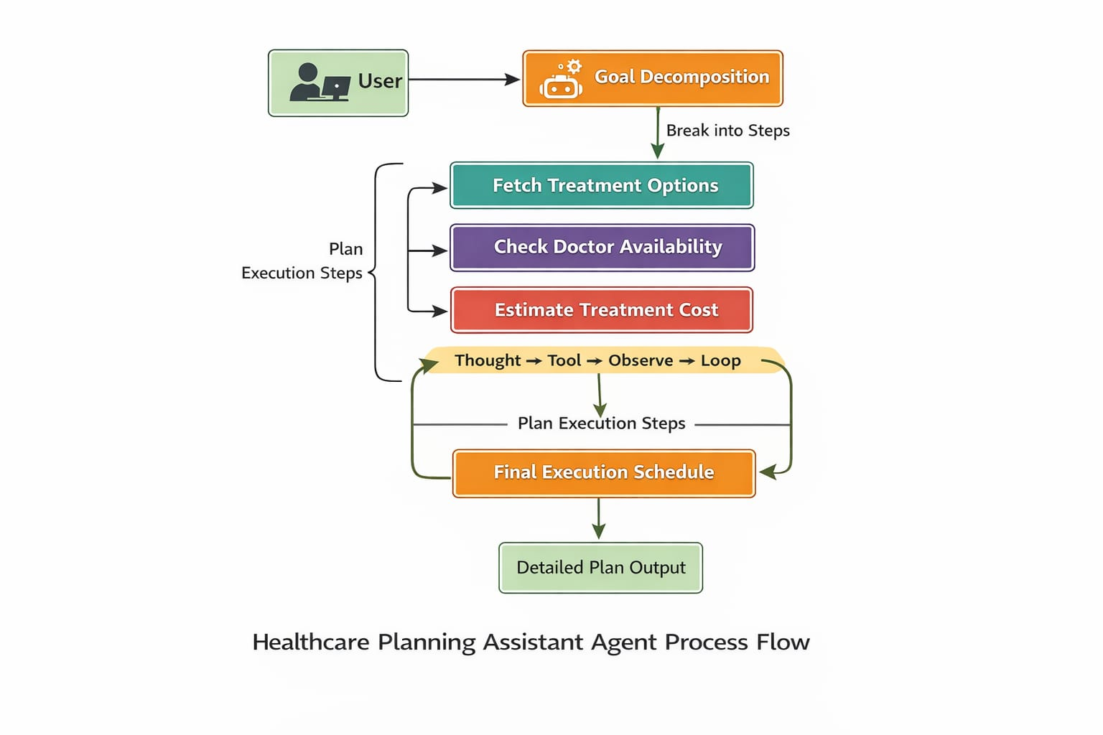

2.3 Information Flow
Input:
- User query (goal)
- Optional patient or context data
Internal Flow:
- Input → LLM Processing → Task Decomposition → Tool Interaction → Plan Generation
Output:
- Structured execution plan including:
  - Task list
  - Dependencies
  - Execution schedule

2.4 Components Design
The system consists of the following core components:
1. Planner Agent
- Main intelligence unit
- Performs reasoning and planning

2. Task Manager
- Tracks tasks, status, and dependencies

3. Tool Interface Layer
- Connects to mock healthcare services
- Simulates real-world APIs
4. Execution Engine
- Executes tasks in correct order
- Handles failures and retries
5. LLM Wrapper
- Manages communication with LLM APIs
- Handles prompts and responses
6. Memory Module
- Stores context, history, and intermediate results
7. Scheduler
- Optimizes task sequence and timing
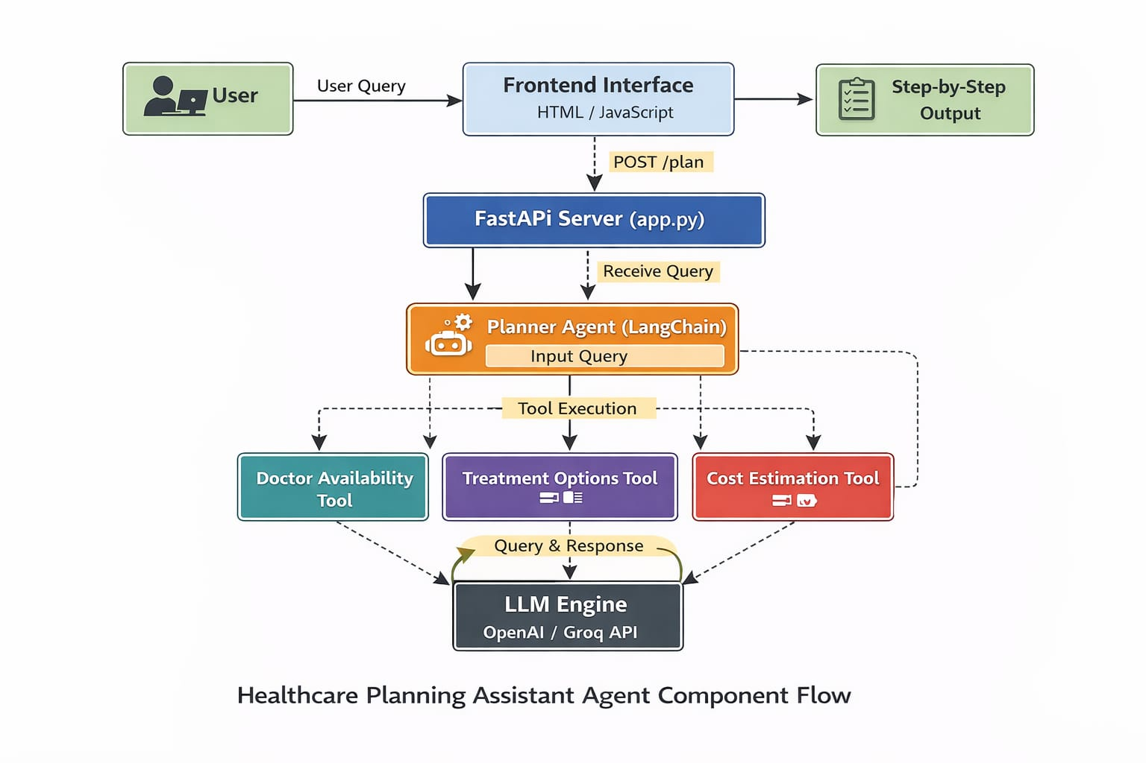

2.5 Key Design Considerations
1. Scalability
- Modular architecture supports expansion
- Can be extended to microservices
2. Reliability
- Error handling and retry mechanisms
- Validation before execution
3. Explainability
- Transparent reasoning steps
- Traceable decision-making
4. Security
- Safe handling of healthcare data
- API authentication and access control
5. Extensibility
- Easy addition of new tools/services
6. Performance
- Parallel execution where possible
- Caching frequently used results

2.6 API Catalogue
1. Submit Goal API
POST /submit-goal
- Accepts user goal
- Returns plan ID

2. Get Plan API
GET /plan/{plan_id}
- Returns generated execution plan
3. Treatment API (Mock Tool)
GET /treatments?condition={condition}
- Fetches treatment options
4. Doctor Availability API
GET /doctors?specialization={type}
- Returns available doctors
5. Task Status API
GET /task-status/{task_id}
- Provides task progress
6. Execute Plan API
POST /execute-plan
- Triggers execution of generated plan

2.7 UML Diagram
